Lab 3 CCS3101
11 April 2025
- Solve the following questions and demonstrate your solutions to me in this lab, the next lab (preferred) or at the the start of the lab after next. This is a 2-weeks lab. For record-keeping, submit also your solutions and screenshots of their output to PutraBlast.
- Evaluation will be done according to the lab rubric on PutraBlast. I will ask questions accordingly.
*******************************

Questions:

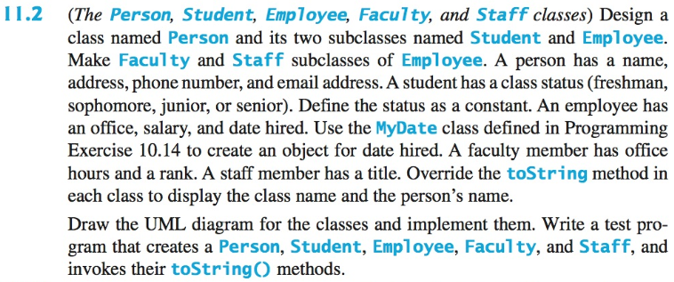

Note that:
- You need to define the student's class statuses as Java constants.
- Instead of the MyDate class in Programming Exercise 10.14, you can implement a simpler MyDate class that just has day, month and year fields, an appropriate constructor and a toString() method.

(This question is from the 10th edition of the Liang textbook. The corresponding question in the 11th edition are the same as far as I know, including the Programming Exercise for the MyDate class.)

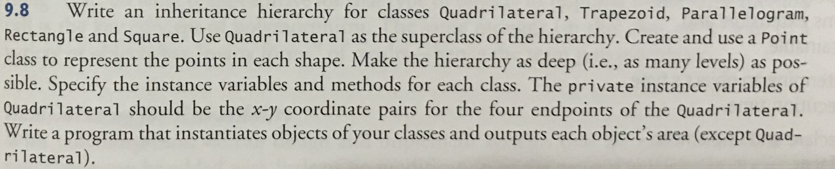

Note that:
- You can use the Shoelace algorithm [1, 2] to calculate the areas of a Trapezoid, Parallelogram, Rectangle, and Square. Please test your implementation properly.

[1] Wikipedia, The Shoelace Algorithm. https://en.wikipedia.org/wiki/Shoelace_formula. Accessed on 7 April 2025.
[2] Sanfoundry, Java Program to Implement Shoelace Algorithm. https://www.sanfoundry.com/java-program-shoelace-algorithm/. Accessed on 7 April 2025.

(This question is from the 9th edition of the Deitel and Deitel textbook.)

